1)Install nginx and run nginx on port number 81.
# example SSH (change user and IP)
ssh -i ~/path/to/your-key.pem ec2-user@EC2_PUBLIC_IP
# update packages
sudo yum update -y

# install nginx
sudo yum install -y nginx

# start & enable at boot
sudo systemctl start nginx
sudo systemctl enable nginx

# check status
sudo systemctl status nginx
##optional
# view nginx default page files
ls -l /usr/share/nginx/html
# nginx configuration test
sudo nginx -t

# reload after config changes
sudo systemctl reload nginx

# view access logs (live)
sudo tail -f /var/log/nginx/access.log
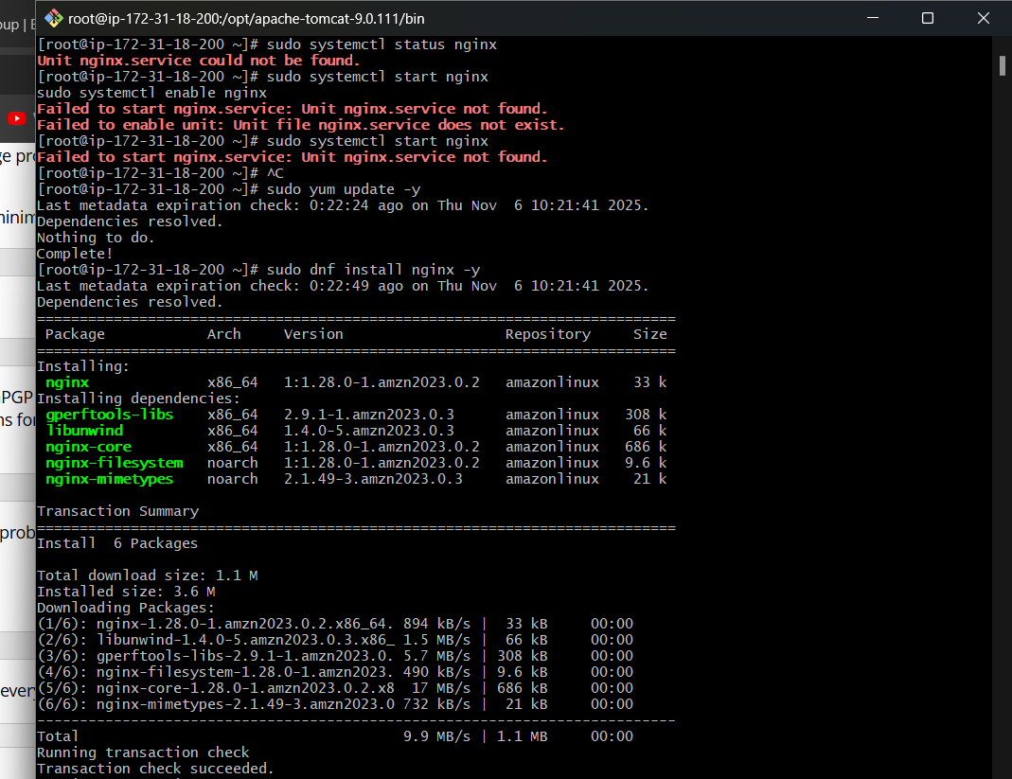
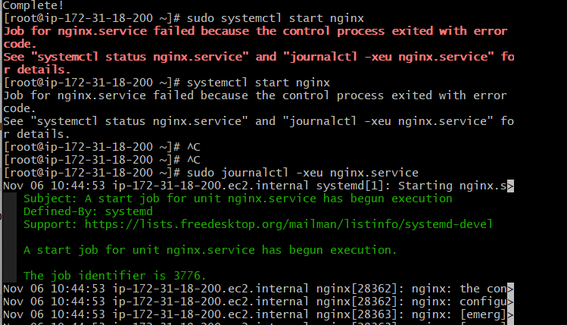

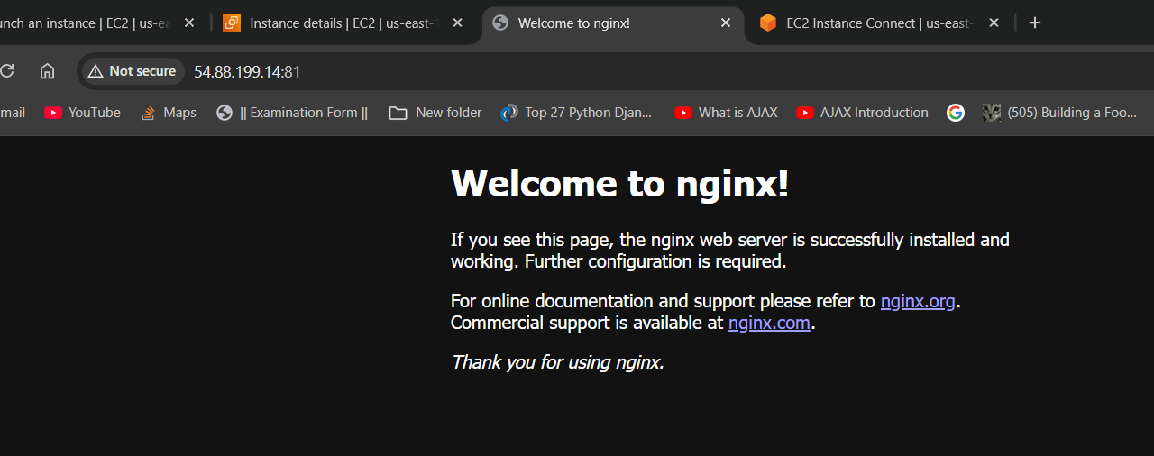

2)Deploy a sample index.html file on nginx.

cd /usr/share/nginx/html
sudo nano index.html
sudo systemctl restart nginx
sudo systemctl status nginx

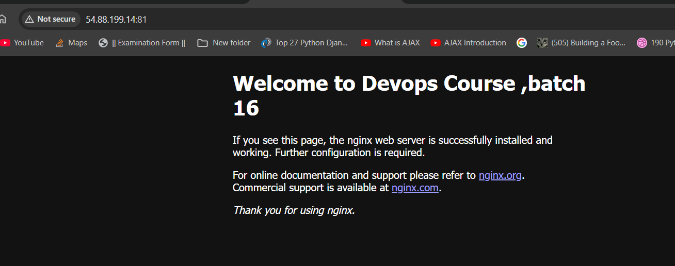

3)Install Apache and run Apache on port number 82

sudo yum install httpd -y
sudo systemctl start httpd
sudo systemctl enable httpd
systemctl status httpd
#sudo sed -i 's/^Listen 80/Listen 82/' /etc/httpd/conf/httpd.conf (for direct edit)
ii: Run Apache on Port 82 Instead of Port 80

Edit Apache Port Configuration
sudo nano /etc/httpd/conf/httpd.conf
change listen 80 to listen 82
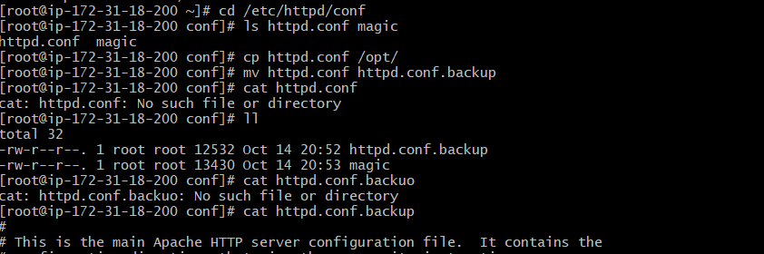
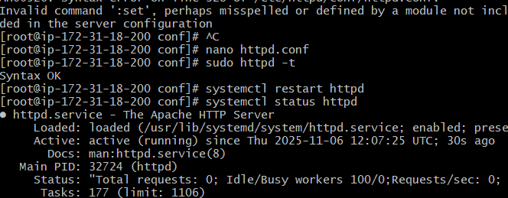

4)Deploy a sample index.html file on Apache.

/var/www/html
cd /var/www/html/
touch index.html
or
sudo nano /var/www/html/index.html
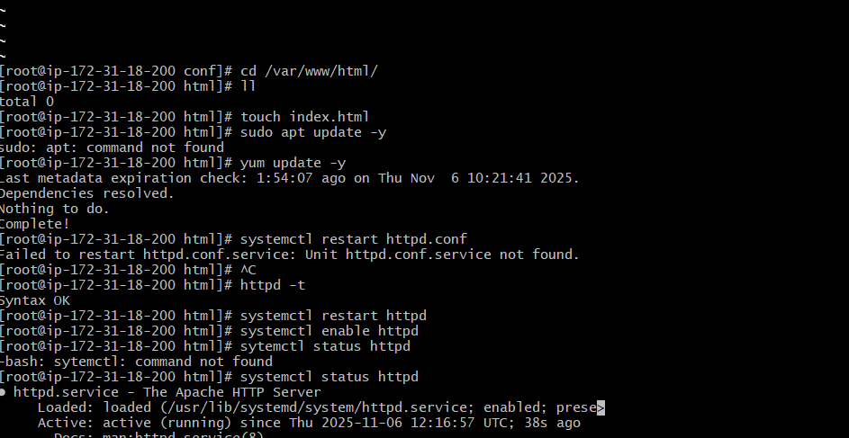
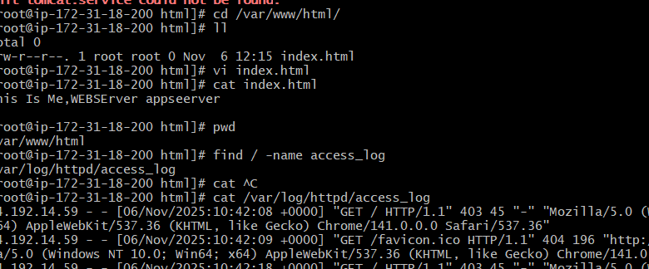

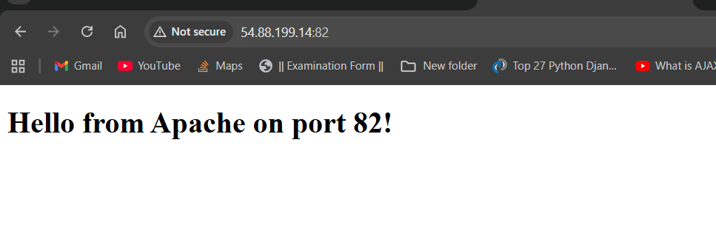
5)Install Apache tomcat on port number 8082
sudo dnf install java-21-amazon-corretto -y
# Update system
sudo yum update -y

# Install Java (required for Tomcat)
sudo yum install -y java-1.8.0-openjdk

# Download Tomcat(tomcat file from tomcat website)
cd /opt
sudo curl -O https://dlcdn.apache.org/tomcat/tomcat-9/v9.0.93/bin/apache-tomcat-9.0.93.tar.gz

# Extract and rename
sudo tar -xvzf apache-tomcat-9.0.93.tar.gz
sudo mv apache-tomcat-9.0.93 tomcat9

# Give execute permissions
sudo chmod +x /opt/tomcat9/bin/*.sh

# Change port from 8080 to 8082
sudo sed -i 's/8080/8082/' /opt/tomcat9/conf/server.xml

# Start tomcat
/opt/tomcat9/bin/startup.sth

# Check process
ps aux | grep tomcat

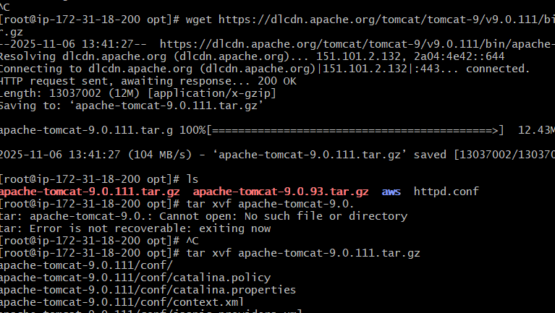

6)Deploy a sample app on webapps
# Go to tomcat webapps directory
cd /opt/tomcat9/webapps

# Download a sample .war file (this is Tomcat sample app)
sudo curl -O https://tomcat.apache.org/tomcat-9.0-doc/appdev/sample/sample.war

# Restart tomcat so it deploys the app
/opt/tomcat9/bin/shutdown.sh

/opt/tomcat9/bin/startup.sh

# Check deployed directory
ls -l /opt/tomcat9/webapps
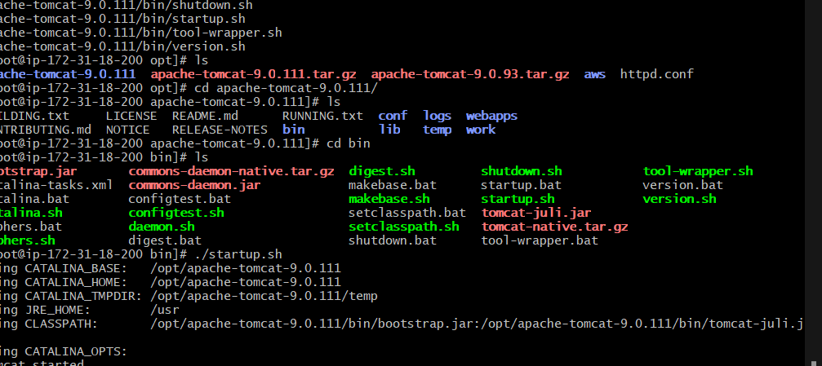

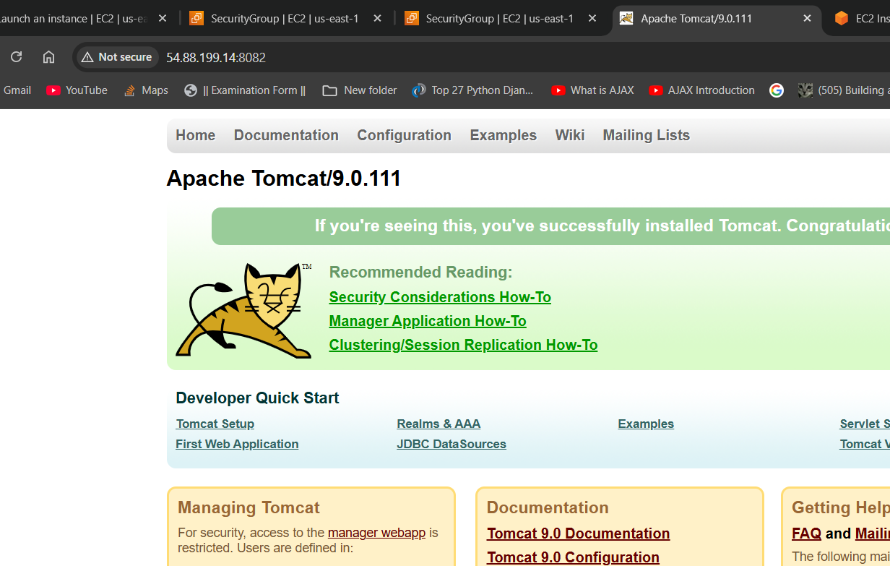
7)Create a tomcat.service file for tomcat.
sudo tee /etc/systemd/system/tomcat.service
sudo systemctl daemon-reload
sudo systemctl start tomcat
sudo systemctl enable tomcat
sudo systemctl status tomcat
8)Configure HA Proxy server
sudo yum install -y haproxy
sudo vi /etc/haproxy/haproxy.cfg
(We have to Replace IPs with our Apache servers IPs)
sudo systemctl start haproxy
sudo systemctl enable haproxy
sudo systemctl status haproxy
